Make New AA test Booking
When do I need to make New AA test booking?
When parents are planning their child to UK boarding school and they have to take AA test and consultation with consultant.

- Go to AA Scheduler and select the date
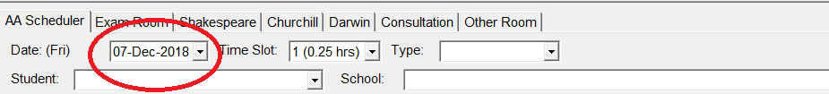
- Select the time slot (15mins each slot),
eg: AA test: 1 student - 4 Slots for AA test (1 hr for consultation)
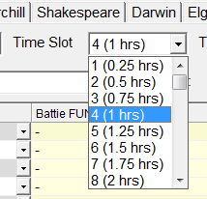
- If 2 students wants to do AA test together, still choose 4 slots, the booking will later appear to creat 6 slots under the same booking for 2 students. (refer to P.3)

- Choose the type of booking,
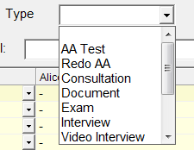
AA Test Consultation
Document Exam
Interview Meeting
Others Redo AA School
Video Interview etc.

- Highlight/select the time which you want to book under the consultant’s name, then right click and select “Add Student with Details”.
eg: If a student applying Year 10 comes at 10:00am for AA test, then select 11:30am to make the booking, as this is the time for consultation with family.

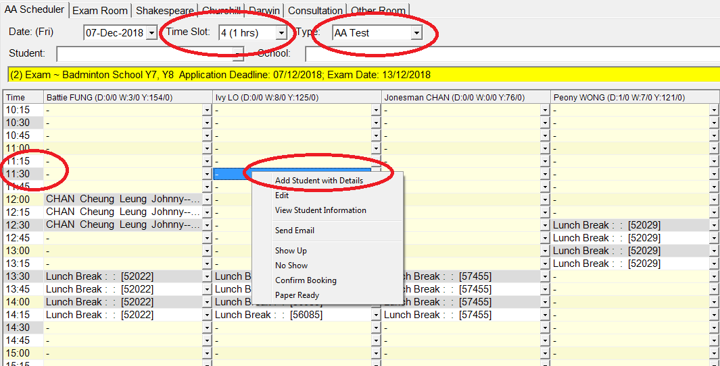

- The below box will come up for you to make basic details of the booking, try to input as much information as possible or at least all the RED info must be input. Then press “Save”.

Please be reminded SURNAME must be in CAPITAL LETTERS and also any contact number no need to input space or ‘-‘ in-between

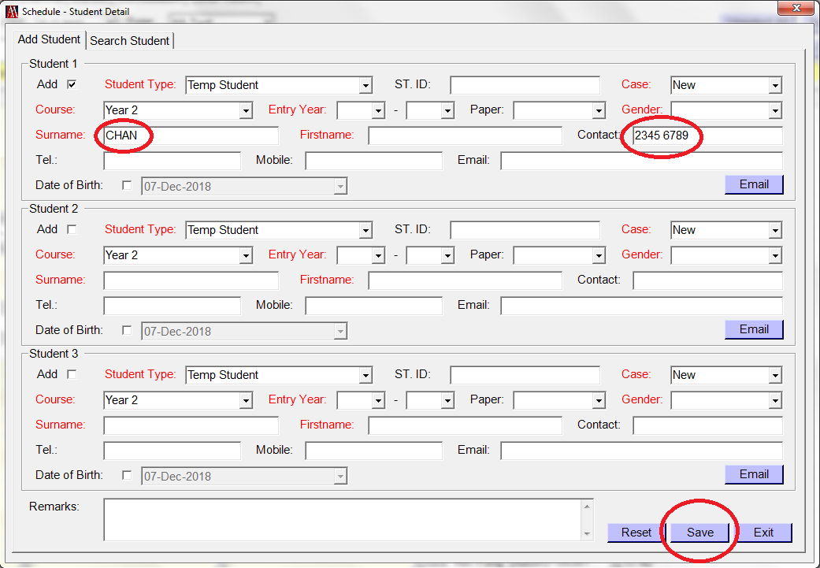
- If more than 2 students want to sit AA test together, ‘’ Add box on the left in ‘student 2/3’, then input booking details. The sys will auto create 6 slots for 2 students or 8 slots for 3 students.
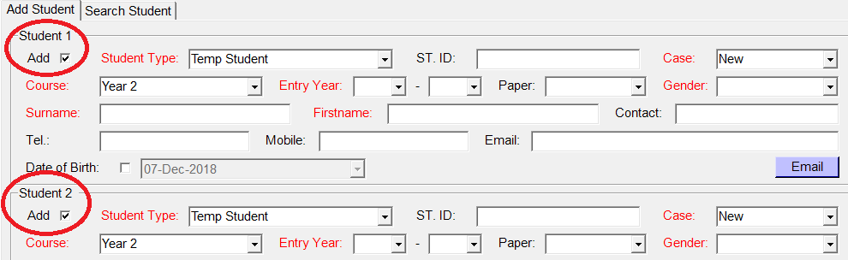

Sometimes if you know the SID already – old case re-active, just change the student type to ‘AA Student’ then key in the SID number and press ‘ENTER’, all the info will fill in automatically as show below, same steps for Temp Student as well.
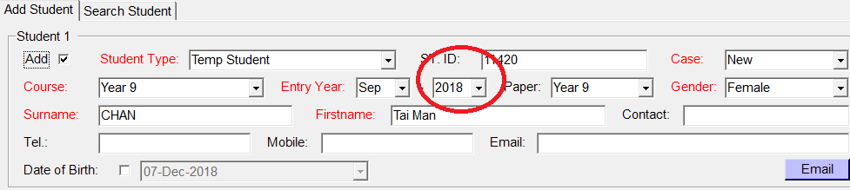
For re-active case, SID should be already opened, please remember to update student file to current entry year, current school, or any other info which needs to be update.
E.g. Tai Man CHAN previously applied Yr 9 Sept 2018 entry and now wants to apply Yr 12 Sept 2020 entry,

- If the data you input is already existed, system will pop up a box telling you which SID it is, then click “NO” for NOT making another file under the same student.
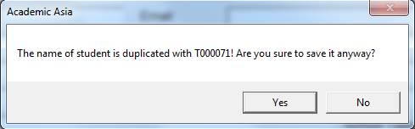

- “Paper” – select the paper which the student should sit on the day.
E.g. Yr 12 Sept 2018 entry – Yr 12 paper
Yr 12 Sept 2021 entry – Yr 10 paper
Foundation – Foundation
If student is not in HK/Consultation only – No paper
*Please refer to the below AA test paper table, entry year will change every MAR 1.
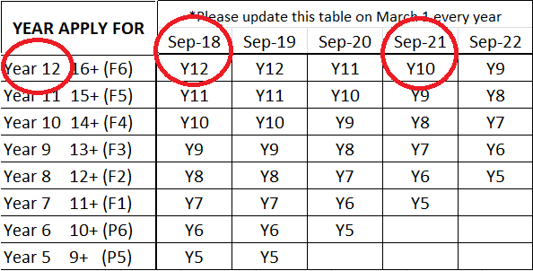

- If student is looking for Foundation course, they don’t need to sit AA Test (unless they are currently F.5 student) but they are still a new AA, therefore please select ‘AA test’ (Green background) when you make the booking and select ‘No Paper’ for this student.
- The booking will show up like this on the scheduler, BUT double check if the time you book is correct then press “Save” again. The booking will then turn from RED wording to GREEN background.
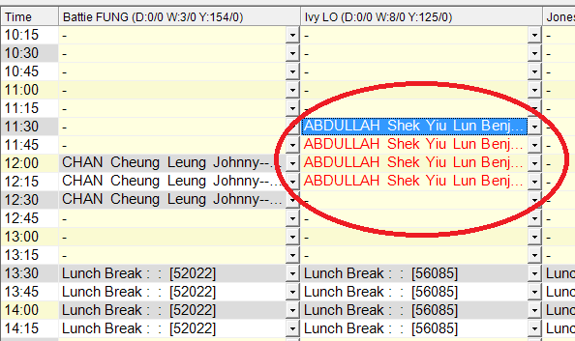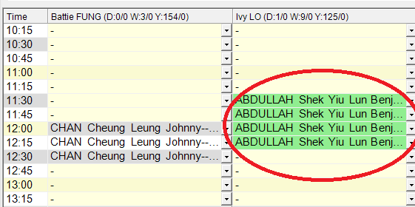
- Very important to press “SAVE” again, otherwise all the information will disappear.

Please be aware of the below difference!!!!!
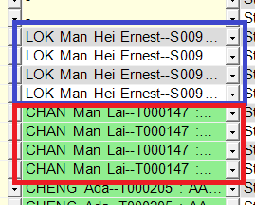
Blue Box (Grey background black wording) for Exam/Re-do/Consultation/interview/school, etc.

Red Box (Green background black wording): AA test only!!
- To input any information you wish other staff to know, highlight the booking, right click then “Edit”
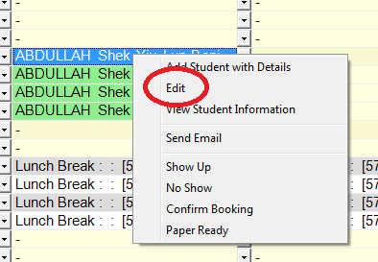
The below box allow you to:
- Change booking time;
- Change consultant;
- Input any remarks.

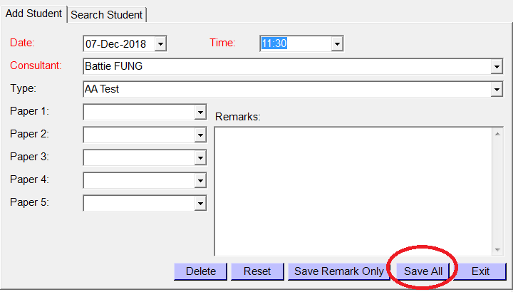
You can put any information you wish all of us to pay attention in the remarks, such as:
- CON only;
- C/O ‘consultant’;
- Request to jump a year;
- Ask for ‘consultant’/DNM (Do Not Move);
- Studying in UK;
- Looking for girls’ school; looking for Stabis; etc.

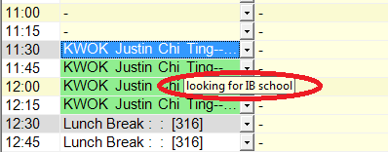
If you want to see the remark of the booking, please click one of the time slots and the remark will be displayed in the small panel, like the one as shown above.

- After all the above steps are done, you can send a confirmation email to parent to confirm the booking. Right click on the booking again and press “Send Email”.
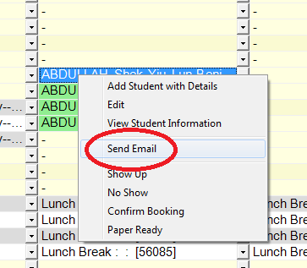
The below box will pop up for you to edit the email before you send out.
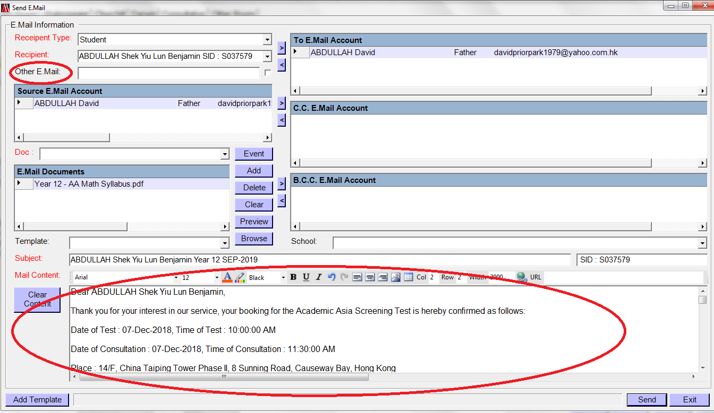
If you want to send the email to more than one email address, you can type in “Other E.mail’, ‘’ the box next to it then press the “>” to move it on the right hand side.

The main content and the Math Syllabus (PDF) will automatically generate for you, you can always edit any details.

The time of the test and interview depends on the type of “Paper” you input at the beginning when you make the booking. Sys will calculate the paper time for you itself. (See P.4)

Year 5-7 papers are 1 hr – Eng writing & Maths
Year 8-12 papers are 1 hr 30 mins – Eng writing, Grammar & Maths

The Math Syllabus (PDF) depends on the paper select (Please see P.4)
Please click delete if the paper is wrong and add (Browse) a new syllabus on it before sent it out.
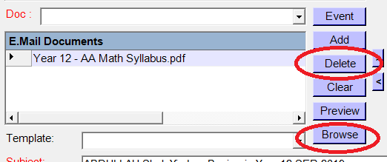

The confirmation email will automatically send a copy to your mail box depending who make the booking

- The day before the families arrive, we call them up to confirm/remind their booking.
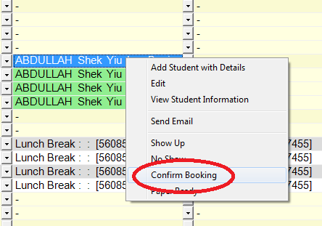
If the family confirmed, just right click the booking, then press ‘Confirm Booking’, it will ask you to refresh, then press ‘Yes’.
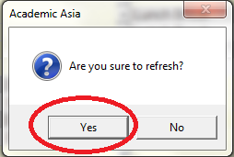
Right click again then press ‘Edit’, in the remark it will show ‘(Confirmed)’. Put your initial after the confirm/cancel booking
e.g. looking for top school (Confirmed - GL)
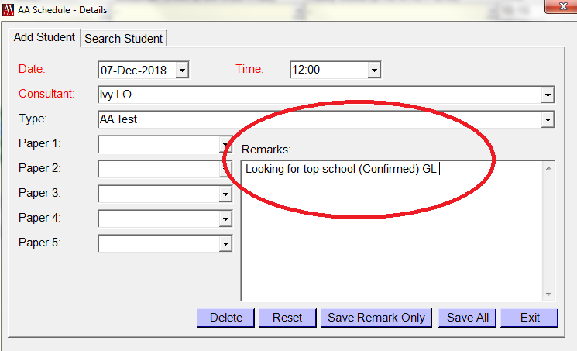
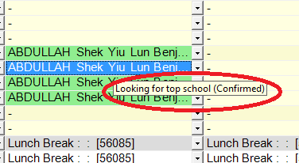
- To view the student file, right click the student name then press ‘View Student Information’.
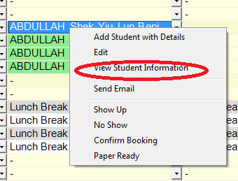

The below profile will pop up for you to see what year the student is applying; what paper student needs to take; etc.

You can edit any information you want in the student profile, but make sure all details are input correctly and also remember to SAVE before you close it.
